

Secuirty

Made by: ENG : Habiba ragab Abdelmoneam

Security Headers

**Tools: Security Headers bt SNK (online tool)**

The security headers are displayed in the HTTP response and indicate the way the browser is suppose to operate in regards to the execution of the HTML. They are checked before the rest of the page.

They can prevent Cross-Site Scripting, clickjacking attacks and information disclosure.

**4**

Security Testing ( SQL injection

and the XSS Vulnerabilities

**Tool: OWASP ZAP**

**Alerts**

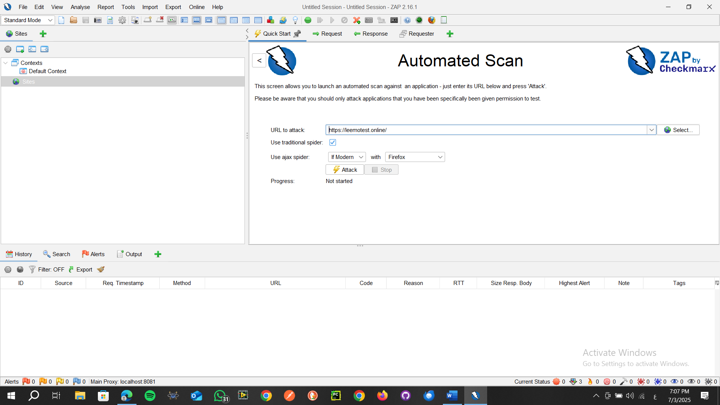

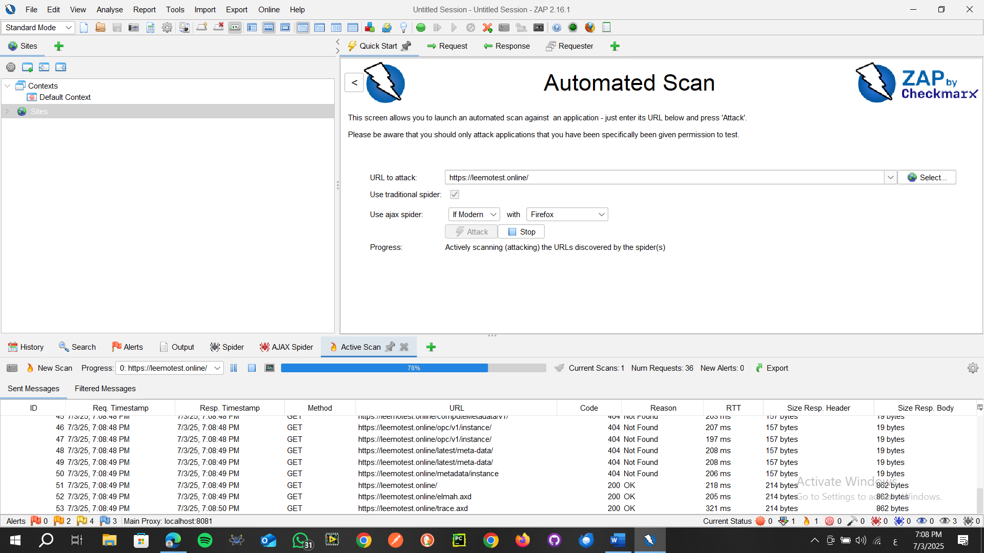

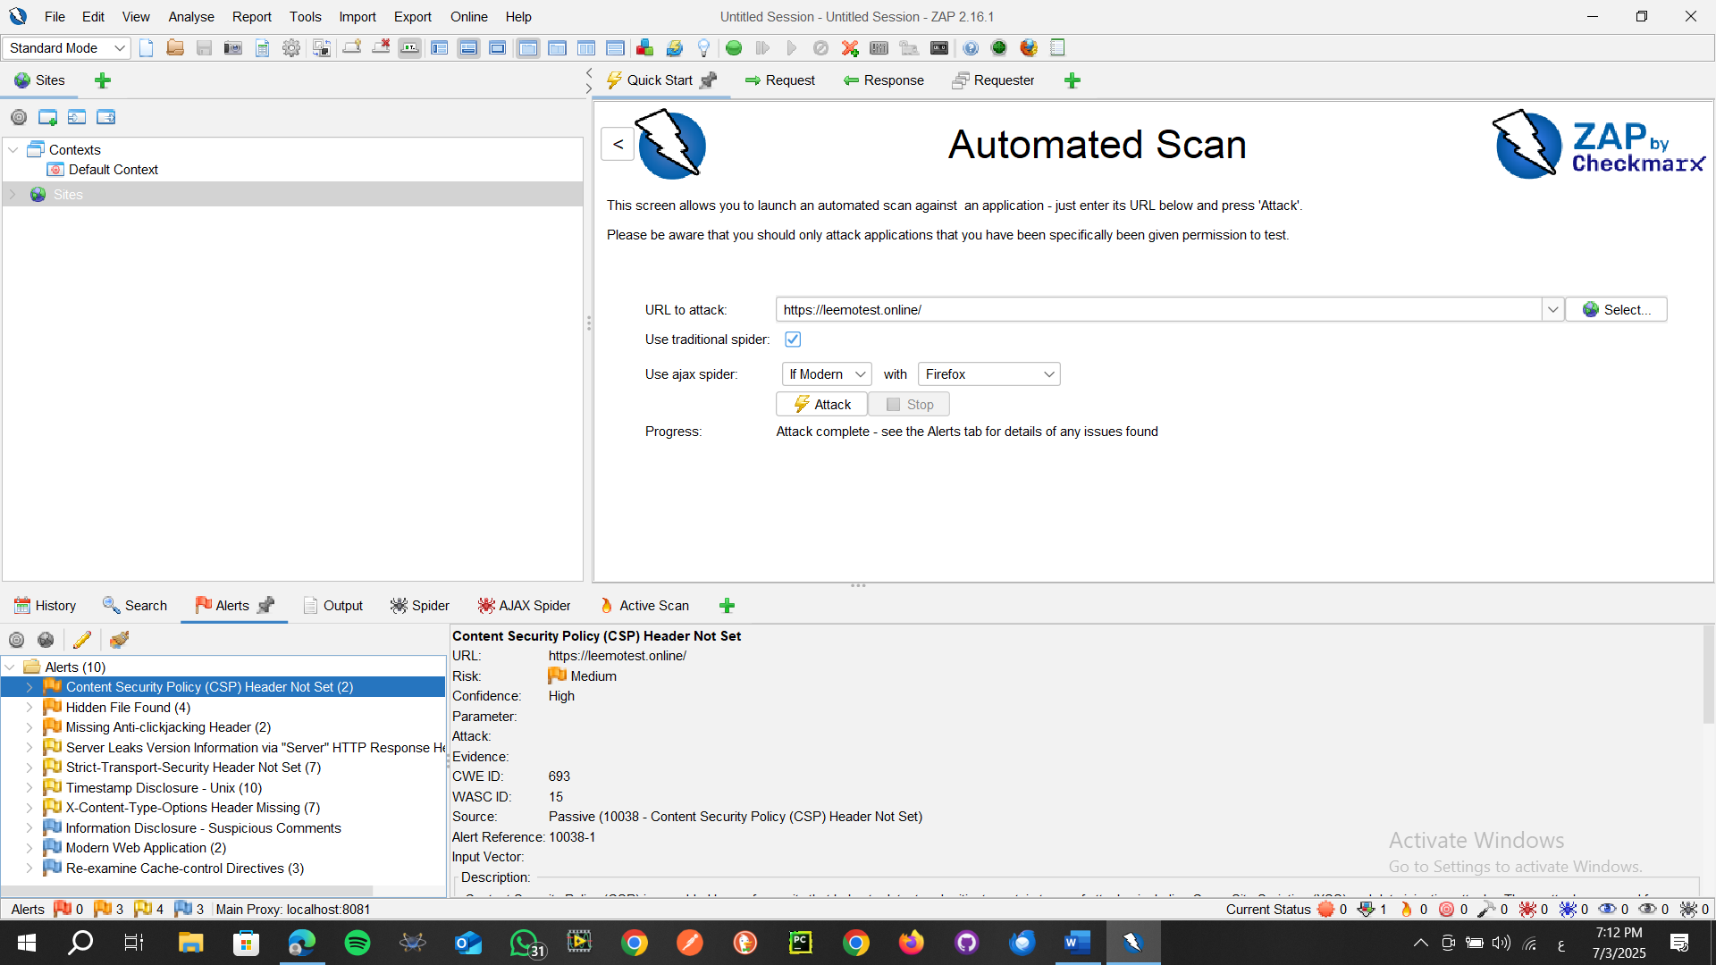

Content Security Policy (CSP) is an added layer of security that helps to detect and mitigate certain types of attacks, including Cross Site Scripting (XSS) and data injection attacks. These attacks are used for everything from data theft to site defacement or distribution of malware. CSP provides a set of standard HTTP headers that allow website owners to declare approved sources of content that browsers should be allowed to load on that page — covered types are JavaScript, CSS, HTML frames, fonts, images and embeddable objects such as Java applets, ActiveX, audio and video files.

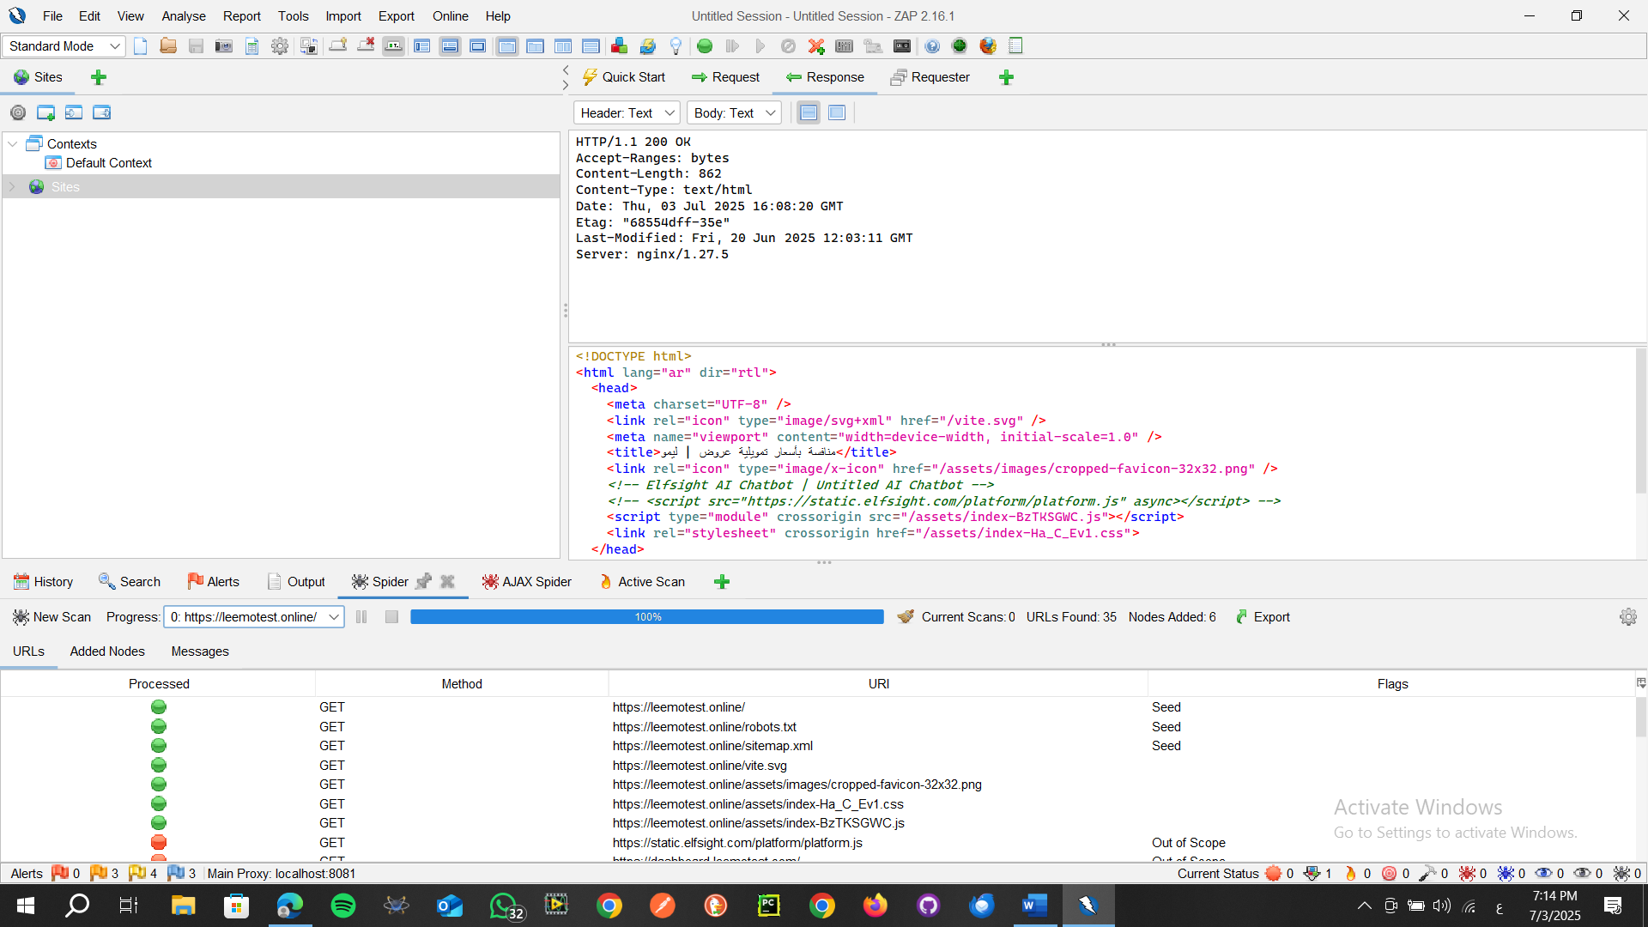

**A sensitive file was identified as accessible or available. This may leak administrative, configuration, or credential information which can be leveraged by a malicious individual to further attack the system or conduct social engineering efforts.**

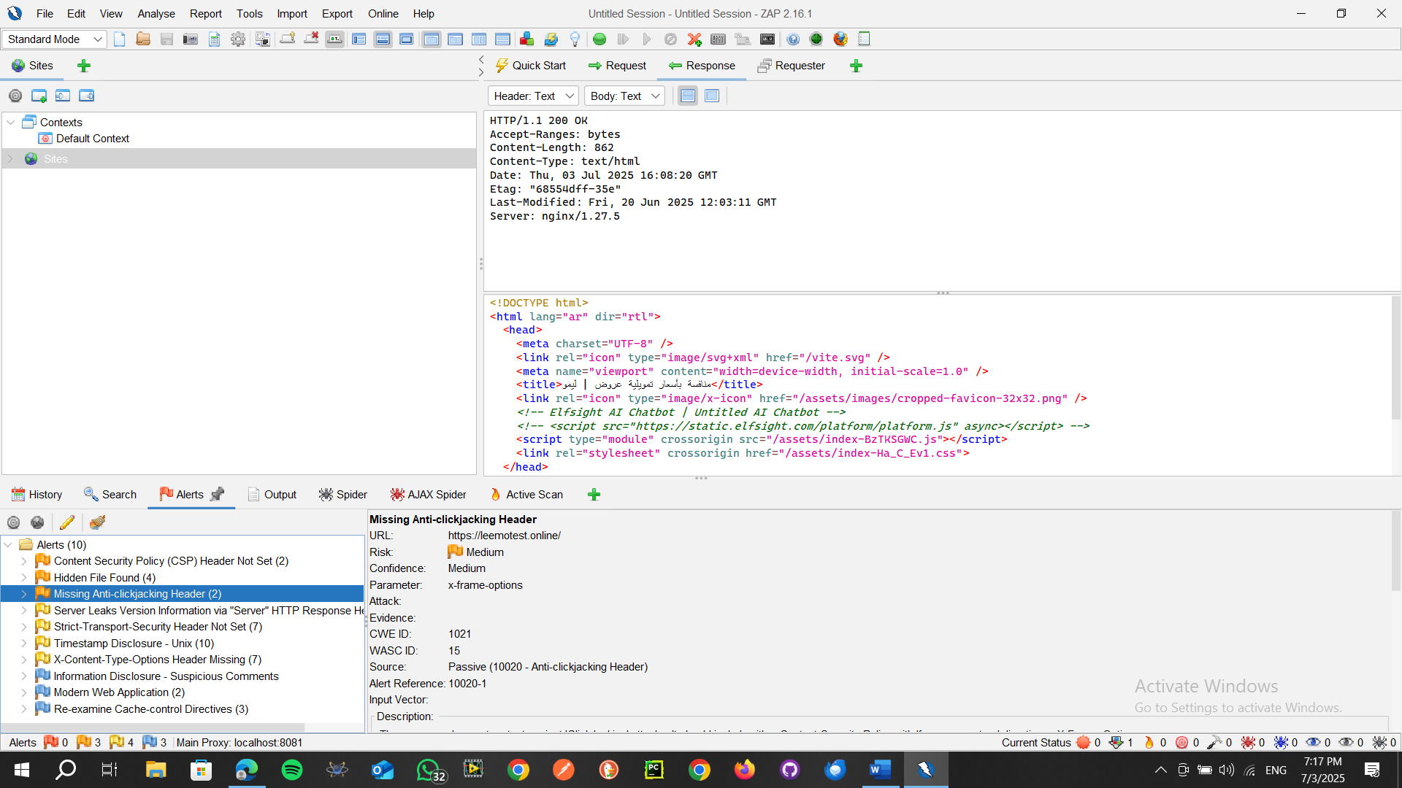 **SOLUTION:** **Consider whether or not the component is actually required in production, if it isn't then disable it. If it is then ensure access to it requires appropriate authentication and authorization, or limit exposure to internal systems or specific source IPs, etc**

The response does not protect against 'ClickJacking' attacks. It should include either Content-Security-Policy with 'frame-ancestors' directive or X-Frame-Options.

**Solution**

Modern Web browsers support the Content-Security-Policy and X-Frame-Options HTTP headers. Ensure one of them is set on all web pages returned by your site/app.

If you expect the page to be framed only by pages on your server (e.g. it's part of a FRAMESET) then you'll want to use SAMEORIGIN, otherwise if you never expect the page to be framed, you should use DENY. Alternatively consider implementing Content Security Policy's "frame-ancestors" directive.

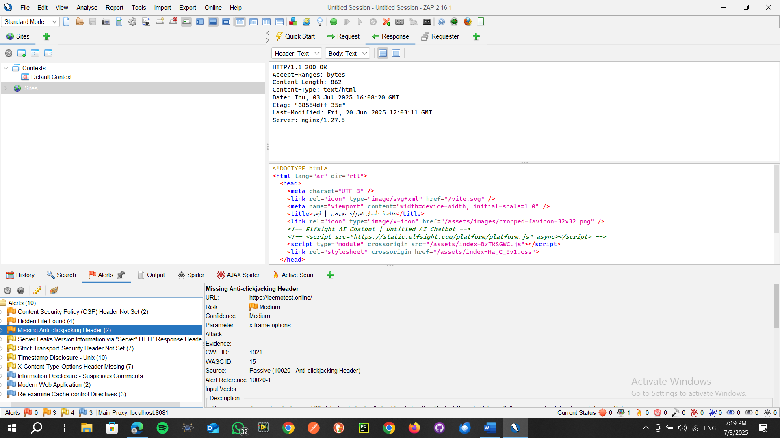

The response does not protect against 'ClickJacking' attacks. It should include either Content-Security-Policy with 'frame-ancestors' directive or X-Frame-Options.

Modern Web browsers support the Content-Security-Policy and X-Frame-Options HTTP headers. Ensure one of them is set on all web pages returned by your site/app.

If you expect the page to be framed only by pages on your server (e.g. it's part of a FRAMESET) then you'll want to use SAMEORIGIN, otherwise if you never expect the page to be framed, you should use DENY. Alternatively consider implementing Content Security Policy's "frame-ancestors" directive.

**Solution:**

Ensure that your web server, application server, load balancer, etc. is configured to suppress the "Server" header or provide generic details.



